AI Usage DISCLOSURE FORM

1. Team Details
Team Name: Chocochipcookies
Project / Product Name: Sam
Organization / Institution (if any): Ramaiah Institute Of Technology
Submission Date: 30 September 2026

2. AI Usage Declaration
Did your team use any Artificial Intelligence (AI) in developing this project?
Yes

3. Purpose of AI Usage ( Brief Details)
Idea generation / brainstorming: No
Code generation or assistance: Yes
UI / UX design: No
Content creation: Yes
Data analysis: No
Testing / debugging: Yes
Other: AI-assisted technical research and Android architecture guidance

4. Feature Origin Classification ( Please add/delete based on the number of the feature)
1. Feature Name: Voice Interaction and Speech-to-Text
2. Self-Generated/AI-Generated/Both: Both
3. Description (include AI tools/platform Used, prompt used, Output Summary, Modification): AI tools/platform used: ChatGPT and Gemini API. Prompts were used for Android VoiceInteractionService/VoiceInteractionSession architecture, speech-to-text integration, audio capture, and voice-state handling. Output Summary: AI-assisted implementation guidance and code for voice interaction and transcription. Modification: the team reviewed, adapted, integrated, and tested the implementation in the Sam Android application.

1. Feature Name: Accessibility-Based Agent Automation
2. Self-Generated/AI-Generated/Both: Both
3. Description (include AI tools/platform Used, prompt used, Output Summary, Modification): AI tools/platform used: ChatGPT and Gemini API. Prompts were used for AccessibilityService architecture, semantic UI extraction, structured actions, routing, loop handling, overlays, and agent execution. Output Summary: AI-assisted architecture and code guidance for the automation agent. Modification: the team integrated and tested the resulting components with the existing Accessibility bridge and agent workflow.

5. Ethical & Compliance Confirmation
AI usage complies with guidelines and policies. Yes
No proprietary or copyrighted data misused. I Agree

6. Declaration & Sign-Off
Name of Team Representative: Priyal Lakhera
Role: Team Representative
Signature:
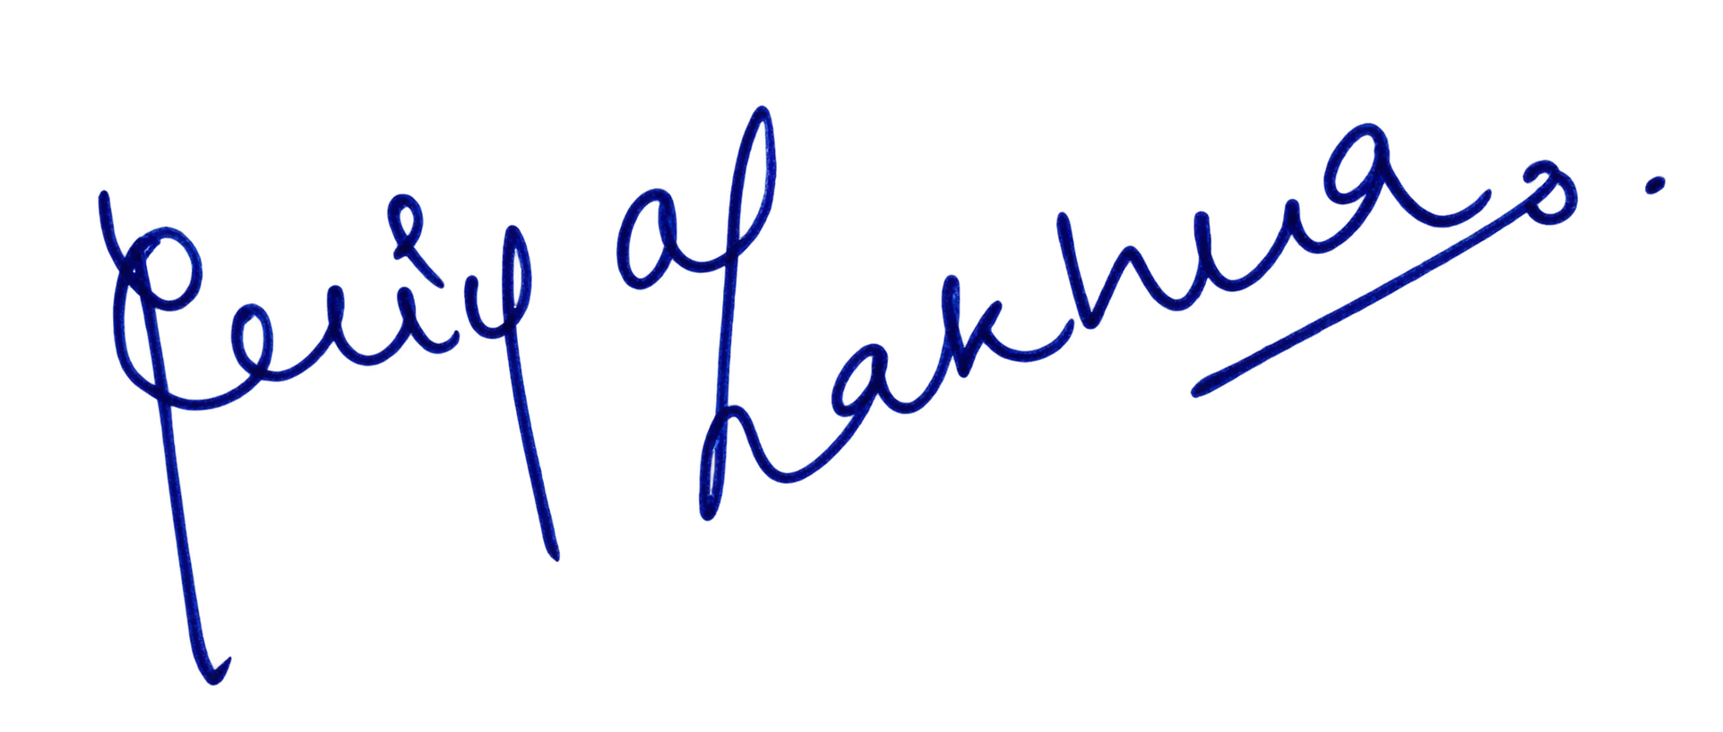
Date: 30 September 2026

